* **SWOT analysis**

This is an analysing method that helps evaluate the strengths, weaknesses, opportunities and threats involved in a certain organisation either internally or externally. Looking at this institute, the SWOT analysis helped me discover their Strength, Weaknesses, Opportunities and Threat.(Anon., 200-2014) When looking at:

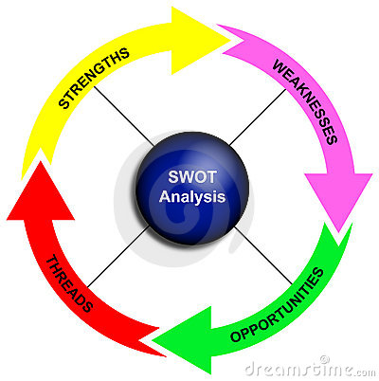

**Strengths**



This focuses on certain positive internal factors of which the organisation possesses. Looking at this institute, there are several internal characteristics that put them at the same level with their competitors or slightly ahead of them.(Anon., 2002-2014). Some of those factors are:

* Some of the external communities around Scotland view them with a positive reputation.
* The institute is filled with dedicated staff members.
* Positive experience with most people that have either been in the institute or had encounter with members of the institute,
* The institute offer a quality assurance of courses with a certification exam result.
* The institute has experienced proficiency and support staff.

**Weaknesses**



These are aspects of the organisation that prevents you from successfully competing with other competitors. Looking at this institute, there are several internal characteristics that put them at the back foot with their competitors and their students and staff.(Anon., 2002-2014)Some of those factors are:

* There is a high dependency on part time lectures in some of the institute’s faculties.
* The institute libraries are not good enough because they do not have updated resources.
* The recruitment process for international students has little emphasis.
* The institute has not much of space for future expansion.

**Opportunities**

These are external factors that shows how likely an organisation is to succeed. Looking at this institute, there are several external characteristics that put them at the same level with their competitors or slightly ahead of them.(Anon., 2002-2014) Some of these factors are:

* There is a high demand for mid-career redirection and lifelong learning.
* There is an increase on the value of higher education completion.
* There is a growth in demand for graduates are the country.
* There are opportunities for partnership with other companies/banks.

**Threat**



These are external factors that may prevent the growth of an organisation. Looking at this institute, there are several external factors that put them at the risk of being behind their competitors.(Anon., 2008) These factors are:

* The improvement of other institute around the country.
* The public perception is negative.
* The perception of education to students is nothing other than getting a job.
* Experienced staff could be leaving for better conditions in other industries.

**PESTEL**

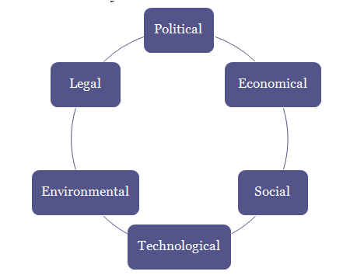

This is an analysing tool that evaluates the political, economic, social, Technological, environmental and legal aspects in relation to an organisation(Jurevicius, 2013). Looking at this institute, PESTEL analysis played a bigger role in the process of finding out the political, economic, social, technological, environmental and legal factor that affect the institute. When looking at:

* **Political factors**

Thesearefactors that deal with the government rules and policies in relation to the organisation. Looking at this institute, there are several political factors that affect their functionality. These factors are:

* The country’s tax policies;
* Human resources and employees’ handbook are affected by the government employment laws.
* With Scotland being part of England, there are currently politically unstable because whatever law they can come up with, will have to be linked with the English law.
* The country’s infrastructure policies.

With the amount of students enrolled with the institute, it will sort of be hard for the institute to focus on paying policies monthly, meet the country’s infrastructure policies and to help their graduate meet the government employment policies.

* **Economic factors**

These are factors that deal with the government financial rules and policies in relation to the organisation. Looking at this institute, there are several economic factors that affect their functionality. These factors are:

* The country’s growth in economy.
* The country’s policy about unemployment.
* The inflation rate
* The phases of business cycle.

With an increase in the inflation rate and the country’s economy, the institute will be force to increase their fees and other expenses with which by doing that, their raw materials will also be more costly.

* **Social factors**

These are factors that deal with the country’s social rules and policies in relation to the organisation. Looking at this institute, there are several social factors that affect their functionality. These factors are:

* An increase in population growth.
* Change in fashion.
* The population’s living conditions.
* The changes in demography.

With the current institute size, it will be difficult to recruit new student and match the population living conditions because it will be hard to make it bigger.

* **Technological factors**

These are factors that deal with the country’s technological rules and policies in relation to the organisation. Looking at this institute, there are several technological factors that affect their functionality. These factors are:

* Changes in the county’s information technology policy.
* Changes in the mobile technology
* New creations.

With the current technological problems of the institute, it is very difficult to match the country’s development in technology which leads them to still using the old hardware and software.

* **Legal factors**

These are factors that deal with the country’s legislative rules and policies in relation to the organisation. Looking at this institute, there are several legislative factors that affect their performances. These factors are:

* The country’s safety regulation.
* The laws on employment.
* The tax policies.

With the current situation at institute, it is really hard for them to meet the safety rules and regulations.

* **Environmental factors**

These are factors that deal with the country’s environment rules and policies in relation to the organisation. Looking at this institute, there are several environmental factors that affects their performances. These factors are:

* Climate changes.
* The country’s environmental regulation.
* Waste management.
* Management of their resources.
* Pollution regulation.

In order for them to get rid of papers and some useless books, the institute order their workers to burn them right on their premises resulting to pollution and poor waste management.

**MOST Analysis**

This is an analysing tool used to clarify an organisation mission, objective, strategies and tactics. Looking at this institute, the MOST analysis helped frame out their Mission, Objective, Strategy and Tactics on how to improve the institute. When looking at:

* **Mission**

This defines the benefit and goals of an organisation. When looking at this institute, their missions are to:

* Prepare their student to understand and succeed in the rapid improvement of our society.
* Help their students to develop potential trough exposure to a range of academic, sporting and cultural activities.
* To enhance excellence in practice and teaching.
* **Objectives**

This defines the translation of the mission into specific measurable, achievable and timely component. Looking at this institute, their objectives are:

* To become among the best institute in the world.
* To cultivate and sustain an integrated disciplinary institute that facilitates creative teaching and learning method.
* To provide good educational resources for a safe and challenging community at which students are willing to participate.
* Prepare their students to be independent and skilful communicators.
* **Strategic**

This is one of MOST analysis that helps an organisation plan their designed actions to achieve a long term or overall aim.

Looking at this institute, their strategies are:

* To increase the institute market share.
* Strengthening the institute financial resources
* Improving their teaching methods.
* Improving the institute infrastructure.
* **Tactical**

This is one of MOST analysis that helps an organisation put into action a well planes strategy. Looking at this institute, after finding out their missions, objectives and strategies, I used this stage to figure out they planned to achieve them. (Health, 2014) Their tactics are:

* Increase the institute profits by restricting jobs to avoid redundancy.
* Improve their market share by investing heavily on advertisement.
* Making sure that their products are in an effective quality by controlling them. By doing this, they managed to cut down cost related with waste.

The current cohorts together with specialise curriculum, the institute is strategically well positioned for sustainable growth and development in the next few years.

**Creating S.M.A.R.T. Goals**

Specific

Measurable

Attainable

Realistic

Timely

**Specific:** A specific goal has a much greater chance of being accomplished than a general goal. To set a specific goal you must answer the six “W” questions:

*Who:      Who is involved?

*What:     What do I want to accomplish?

*Where:    Identify a location.

*When:     Establish a time frame.

*Which:    Identify requirements and constraints.

*Why:      Specific reasons, purpose or benefits of accomplishing the goal.

EXAMPLE:  A general goal would be, “Get in shape.” But a specific goal would say, “Join a health club and workout 3 days a week.”

**Measurable -** Establish concrete criteria for measuring progress toward the attainment of each goal you set.

When you measure your progress, you stay on track, reach your target dates, and experience the exhilaration of achievement that spurs you on to continued effort required to reach your goal.

To determine if your goal is measurable, ask questions such as……

How much? How many?

How will I know when it is accomplished?

**Attainable** – When you identify goals that are most important to you, you begin to figure out ways you can make them come true. You develop the attitudes, abilities, skills, and financial capacity to reach them. You begin seeing previously overlooked opportunities to bring yourself closer to the achievement of your goals.

You can attain most any goal you set when you plan your steps wisely and establish a time frame that allows you to carry out those steps. Goals that may have seemed far away and out of reach eventually move closer and become attainable, not because your goals shrink, but because you grow and expand to match them. When you list your goals you build your self-image. You see yourself as worthy of these goals, and develop the traits and personality that allow you to possess them.

**Realistic**- To be realistic, a goal must represent an objective toward which you are both *willing* and *able* to work. A goal can be both high and realistic; you are the only one who can decide just how high your goal should be. But be sure that every goal represents substantial progress.

A high goal is frequently easier to reach than a low one because a low goal exerts low motivational force. Some of the hardest jobs you ever accomplished actually seem easy simply because they were a labor of love.

**Timely** – A goal should be grounded within a time frame. With no time frame tied to it there’s no sense of urgency. If you want to lose 10 lbs, when do you want to lose it by? “Someday” won’t work. But if you anchor it within a timeframe, “by May 1st”, then you’ve set your unconscious mind into motion to begin working on the goal.  
Your goal is probably realistic if you truly believe that it can be accomplished. Additional ways to know if your goal is realistic is to determine if you have accomplished anything similar in the past or ask yourself what conditions would have to exist to accomplish this goal.past or ask yourself what conditions would have to exist to accomplish this goal.